UNIT – I
Different Types of Big Data Analytics
Here are the four types of Big Data analytics:

1. Descriptive Analytics
This summarizes past data into a form that people can easily read. This helps in creating reports, like a company’s revenue, profit, sales, and so on. Also, it helps in the tabulation of social media metrics.
Use Case: The Dow Chemical Company analyzed its past data to increase facility utilization across its office and lab space. Using descriptive analytics, Dow was able to identify underutilized space. This space consolidation helped the company save nearly US $4 million annually.

2. Diagnostic Analytics
This is done to understand what caused a problem in the first place. Techniques like drill-down, data mining, and data recovery are all examples. Organizations use diagnostic analytics because they provide an in-depth insight into a particular problem.
Use Case: An e-commerce company’s report shows that their sales have gone down, although customers are adding products to their carts. This can be due to various reasons like the form didn’t load correctly, the shipping fee is too high, or there are not enough payment options available. This is where you can use diagnostic analytics to find the reason.

3. Predictive Analytics
This type of analytics looks into the historical and present data to make predictions of the future. Predictive analytics uses data mining, AI, and machine learning to analyze current data and make predictions about the future. It works on predicting customer trends, market trends, and so on.
Use Case: PayPal determines what kind of precautions they have to take to protect their clients against fraudulent transactions. Using predictive analytics, the company uses all the historical payment data and user behavior data and builds an algorithm that predicts fraudulent activities.

4. Prescriptive Analytics
This type of analytics prescribes the solution to a particular problem. Perspective analytics works with both descriptive and predictive analytics. Most of the time, it relies on AI and machine learning.
Use Case: Prescriptive analytics can be used to maximize an airline’s profit. This type of analytics is used to build an algorithm that will automatically adjust the flight fares based on numerous factors, including customer demand, weather, destination, holiday seasons, and oil prices.
What is Big Data?
According to Gartner, the definition of Big Data –
“Big data” is high-volume, velocity, and variety information assets that demand cost-effective,
innovative forms of information processing for enhanced insight and decision making.”
This definition clearly answers the “What is Big Data?” question – Big Data refers to complex and
large data sets that have to be processed and analyzed to uncover valuable information that can
benefit businesses and organizations.
However, there are certain basic tenets of Big Data that will make it even simpler to answer what
is Big Data:
• It refers to a massive amount of data that keeps on growing exponentially with time.
• It is so voluminous that it cannot be processed or analyzed using conventional data
processing techniques.
• It includes data mining, data storage, data analysis, data sharing, and data visualization.
• The term is an all-comprehensive one including data, data frameworks, along with the tools
and techniques used to process and analyze the data.
The History of Big Data
Although the concept of big data itself is relatively new, the origins of large data sets go back to
the 1960s and '70s when the world of data was just getting started with the first data centers and
the development of the relational database.
Around 2005, people began to realize just how much data users generated through Facebook,
YouTube, and other online services. Hadoop (an open-source framework created specifically to
store and analyze big data sets) was developed that same year. NoSQL also began to gain
popularity during this time.
The development of open-source frameworks, such as Hadoop (and more recently, Spark) was
essential for the growth of big data because they make big data easier to work with and cheaper to
store. In the years since then, the volume of big data has skyrocketed. Users are still generating
huge amounts of data—but it’s not just humans who are doing it.
With the advent of the Internet of Things (IoT), more objects and devices are connected to the
internet, gathering data on customer usage patterns and product performance. The emergence of
machine learning has produced still more data.
While big data has come far, its usefulness is only just beginning. Cloud computing has expanded
big data possibilities even further. The cloud offers truly elastic scalability, where developers can
simply spin up ad hoc clusters to test a subset of data.
Benefits of Big Data and Data Analytics
• Big data makes it possible for you to gain more complete answers because you have more
information.
• More complete answers mean more confidence in the data—which means a completely
different approach to tackling problems.
Types of Big Data
Now that we are on track with what is big data, let’s have a look at the types of big data:
a) Structured
Structured is one of the types of big data and By structured data, we mean data that can be
processed, stored, and retrieved in a fixed format. It refers to highly organized information that
can be readily and seamlessly stored and accessed from a database by simple search engine
algorithms. For instance, the employee table in a company database will be structured as the
employee details, their job positions, their salaries, etc., will be present in an organized manner.
b) Unstructured
Unstructured data refers to the data that lacks any specific form or structure whatsoever. This
makes it very difficult and time-consuming to process and analyze unstructured data. Email is an
example of unstructured data. Structured and unstructured are two important types of big data.
c) Semi-structured
Semi structured is the third type of big data. Semi-structured data pertains to the data containing
both the formats mentioned above, that is, structured and unstructured data. To be precise, it refers
to the data that although has not been classified under a particular repository (database), yet
contains vital information or tags that segregate individual elements within the data. Thus we come
to the end of types of data.
Characteristics of Big Data
Back in 2001, Gartner analyst Doug Laney listed the 3 ‘V’s of Big Data – Variety, Velocity, and
Volume. Let’s discuss the characteristics of big data.
These characteristics, isolated, are enough to know what big data is. Let’s look at them in depth:
a) Variety
Variety of Big Data refers to structured, unstructured, and semi-structured data that is gathered
from multiple sources. While in the past, data could only be collected from spreadsheets and
databases, today data comes in an array of forms such as emails, PDFs, photos, videos, audios, SM
posts, and so much more. Variety is one of the important characteristics of big data.
b) Velocity
Velocity essentially refers to the speed at which data is being created in real-time. In a broader
prospect, it comprises the rate of change, linking of incoming data sets at varying speeds, and
activity bursts.
c) Volume
Volume is one of the characteristics of big data. We already know that Big Data indicates huge
‘volumes’ of data that is being generated on a daily basis from various sources like social media
platforms, business processes, machines, networks, human interactions, etc. Such a large amount
of data is stored in data warehouses. Thus comes to the end of characteristics of big data.
Why is Big Data Important?
The importance of big data does not revolve around how much data a company has but how a
company utilizes the collected data. Every company uses data in its own way; the more efficiently
a company uses its data, the more potential it has to grow. The company can take data from any
source and analyze it to find answers which will enable:
1. Cost Savings: Some tools of Big Data like Hadoop and Cloud-Based Analytics can
bring cost advantages to business when large amounts of data are to be stored and these
tools also help in identifying more efficient ways of doing business.
2. Time Reductions: The high speed of tools like Hadoop and in-memory analytics can
easily identify new sources of data which helps businesses analyzing data immediately
and make quick decisions based on the learning.
3. Understand the market conditions: By analyzing big data you can get a better
understanding of current market conditions. For example, by analyzing customers’
purchasing behaviors, a company can find out the products that are sold the most and
produce products according to this trend. By this, it can get ahead of its competitors.
4. Control online reputation: Big data tools can do sentiment analysis. Therefore, you
can get feedback about who is saying what about your company. If you want to monitor
and improve the online presence of your business, then, big data tools can help in all
this.
5. Using Big Data Analytics to Boost Customer Acquisition and Retention
The customer is the most important asset any business depends on. There is no single
business that can claim success without first having to establish a solid customer base.
However, even with a customer base, a business cannot afford to disregard the high
competition it faces. If a business is slow to learn what customers are looking for, then
it is very easy to begin offering poor quality products. In the end, loss of clientele will
result, and this creates an adverse overall effect on business success. The use of big data
allows businesses to observe various customer related patterns and trends. Observing
customer behavior is important to trigger loyalty.
6. Using Big Data Analytics to Solve Advertisers Problem and Offer Marketing
Insights
Big data analytics can help change all business operations. This includes the ability to
match customer expectation, changing company’s product line and of course ensuring
that the marketing campaigns are powerful.
7. Big Data Analytics As a Driver of Innovations and Product Development
Another huge advantage of big data is the ability to help companies innovate and
redevelop their products.
Business Intelligence vs Big Data
Although Big Data and Business Intelligence are two technologies used to analyze data to help
companies in the decision-making process, there are differences between both of them. They differ
in the way they work as much as in the type of data they analyze.
Traditional BI methodology is based on the principle of grouping all business data into a central
server. Typically, this data is analyzed in offline mode, after storing the information in an
environment called Data Warehouse. The data is structured in a conventional relational database
with an additional set of indexes and forms of access to the tables (multidimensional cubes).
A Big Data solution differs in many aspects to BI to use. These are the main differences between
Big Data and Business Intelligence:
1. In a Big Data environment, information is stored on a distributed file system, rather than
on a central server. It is a much safer and more flexible space.
2. Big Data solutions carry the processing functions to the data, rather than the data to the
functions. As the analysis is centered on the information, it´s easier to handle larger
amounts of information in a more agile way.
3. Big Data can analyze data in different formats, both structured and unstructured. The
volume of unstructured data (those not stored in a traditional database) is growing at levels
much higher than the structured data. Nevertheless, its analysis carries different challenges.
Big Data solutions solve them by allowing a global analysis of various sources of
information.
4. Data processed by Big Data solutions can be historical or come from real-time sources.
Thus, companies can make decisions that affect their business in an agile and efficient way.
5. Big Data technology uses parallel mass processing (MPP) concepts, which improves the
speed of analysis. With MPP many instructions are executed simultaneously, and since the
various jobs are divided into several parallel execution parts, at the end the overall results
are reunited and presented. This allows you to analyze large volumes of information
quickly.
Big Data vs Data Warehouse
Big Data has become the reality of doing business for organizations today. There is a boom in the
amount of structured as well as raw data that floods every organization daily. If this data is
managed well, it can lead to powerful insights and quality decision making.
Big data analytics is the process of examining large data sets containing a variety of data types to
discover some knowledge in databases, to identify interesting patterns and establish relationships
to solve problems, market trends, customer preferences, and other useful information. Companies
and businesses that implement Big Data Analytics often reap several business benefits. Companies
implement Big Data Analytics because they want to make more informed business decisions.
A data warehouse (DW) is a collection of corporate information and data derived from operational
systems and external data sources. A data warehouse is designed to support business decisions by
allowing data consolidation, analysis and reporting at different aggregate levels. Data is populated
into the Data Warehouse through the processes of extraction, transformation and loading (ETL
tools). Data analysis tools, such as business intelligence software, access the data within the
warehouse.
Hadoop Environment Big Data Analytics
Hadoop is changing the perception of handling Big Data especially the unstructured data. Let’s
know how Apache Hadoop software library, which is a framework, plays a vital role in handling
Big Data. Apache Hadoop enables surplus data to be streamlined for any distributed processing
system across clusters of computers using simple programming models. It truly is made to scale
up from single servers to a large number of machines, each and every offering local computation,
and storage space. Instead of depending on hardware to provide high-availability, the library itself
is built to detect and handle breakdowns at the application layer, so providing an extremely
available service along with a cluster of computers, as both versions might be vulnerable to
failures.
Hadoop Community Package Consists of
• File system and OS level abstractions
• A MapReduce engine (either MapReduce or YARN)
• The Hadoop Distributed File System (HDFS)
• Java ARchive (JAR) files
• Scripts needed to start Hadoop
• Source code, documentation and a contribution section
Activities performed on Big Data
• Store – Big data need to be collected in a seamless repository, and it is not necessary to
store in a single physical database.
• Process – The process becomes more tedious than traditional one in terms of cleansing,
enriching, calculating, transforming, and running algorithms.
• Access – There is no business sense of it at all when the data cannot be searched, retrieved
easily, and can be virtually showcased along the business lines.
Classification of analytics
Descriptive analytics
Descriptive analytics is a statistical method that is used to search and summarize historical data in
order to identify patterns or meaning.
Data aggregation and data mining are two techniques used in descriptive analytics to discover
historical data. Data is first gathered and sorted by data aggregation in order to make the datasets
more manageable by analysts.
Data mining describes the next step of the analysis and involves a search of the data to identify
patterns and meaning. Identified patterns are analyzed to discover the specific ways that learners
interacted with the learning content and within the learning environment.
Advantages:
• Quickly and easily report on the Return on Investment (ROI) by showing how performance
achieved business or target goals.
• Identify gaps and performance issues early - before they become problems.
• Identify specific learners who require additional support, regardless of how many students
or employees there are.
• Identify successful learners in order to offer positive feedback or additional resources.
• Analyze the value and impact of course design and learning resources.
Predictive analytics
Predictive Analytics is a statistical method that utilizes algorithms and machine learning to identify
trends in data and predict future behaviors
The software for predictive analytics has moved beyond the realm of statisticians and is becoming
more affordable and accessible for different markets and industries, including the field of learning
& development.
For online learning specifically, predictive analytics is often found incorporated in the Learning
Management System (LMS), but can also be purchased separately as specialized software.
For the learner, predictive forecasting could be as simple as a dashboard located on the main screen
after logging in to access a course. Analyzing data from past and current progress, visual indicators
in the dashboard could be provided to signal whether the employee was on track with training
requirements.
Advantages:
• Personalize the training needs of employees by identifying their gaps, strengths, and
weaknesses; specific learning resources and training can be offered to support individual
needs.
• Retain Talent by tracking and understanding employee career progression and forecasting
what skills and learning resources would best benefit their career paths. Knowing what skills
employees need also benefits the design of future training.
• Support employees who may be falling behind or not reaching their potential by offering
intervention support before their performance puts them at risk.
• Simplified reporting and visuals that keep everyone updated when predictive forecasting
is required.
Prescriptive analytics
Prescriptive analytics is a statistical method used to generate recommendations and make decisions
based on the computational findings of algorithmic models.
Generating automated decisions or recommendations requires specific and unique algorithmic
models and clear direction from those utilizing the analytical technique. A recommendation cannot
be generated without knowing what to look for or what problem is desired to be solved. In this
way, prescriptive analytics begins with a problem.
Example
A Training Manager uses predictive analysis to discover that most learners without a particular
skill will not complete the newly launched course. What could be done? Now prescriptive analytics
can be of assistance on the matter and help determine options for action. Perhaps an algorithm can
detect the learners who require that new course, but lack that particular skill, and send an automated
recommendation that they take an additional training resource to acquire the missing skill.
The accuracy of a generated decision or recommendation, however, is only as good as the quality
of data and the algorithmic models developed. What may work for one company’s training needs
may not make sense when put into practice in another company’s training department. Models are
generally recommended to be tailored for each unique situation and need.
Descriptive vs Predictive vs Prescriptive Analytics
Descriptive Analytics is focused solely on historical data.
You can think of Predictive Analytics as then using this historical data to develop statistical models
that will then forecast about future possibilities.
Prescriptive Analytics takes Predictive Analytics a step further and takes the possible forecasted
outcomes and predicts consequences for these outcomes.
What Big Data Analytics Challenges
1. Need For Synchronization Across Disparate Data Sources
As data sets are becoming bigger and more diverse, there is a big challenge to incorporate them
into an analytical platform. If this is overlooked, it will create gaps and lead to wrong messages
and insights.
2. Acute Shortage Of Professionals Who Understand Big Data Analysis
The analysis of data is important to make this voluminous amount of data being produced in every
minute, useful. With the exponential rise of data, a huge demand for big data scientists and Big
Data analysts has been created in the market. It is important for business organizations to hire a
data scientist having skills that are varied as the job of a data scientist is multidisciplinary. Another
major challenge faced by businesses is the shortage of professionals who understand Big Data
analysis. There is a sharp shortage of data scientists in comparison to the massive amount of data
being produced.
3. Getting Meaningful Insights Through The Use Of Big Data Analytics
It is imperative for business organizations to gain important insights from Big Data analytics, and
also it is important that only the relevant department has access to this information. A big challenge
faced by the companies in the Big Data analytics is mending this wide gap in an effective manner.
4. Getting Voluminous Data Into The Big Data Platform
It is hardly surprising that data is growing with every passing day. This simply indicates that
business organizations need to handle a large amount of data on daily basis. The amount and
variety of data available these days can overwhelm any data engineer and that is why it is
considered vital to make data accessibility easy and convenient for brand owners and managers.
5. Uncertainty Of Data Management Landscape
With the rise of Big Data, new technologies and companies are being developed every day.
However, a big challenge faced by the companies in the Big Data analytics is to find out which
technology will be best suited to them without the introduction of new problems and potential
risks.
6. Data Storage And Quality
Business organizations are growing at a rapid pace. With the tremendous growth of the companies
and large business organizations, increases the amount of data produced. The storage of this
massive amount of data is becoming a real challenge for everyone. Popular data storage options
like data lakes/ warehouses are commonly used to gather and store large quantities of unstructured
and structured data in its native format. The real problem arises when a data lakes/ warehouse try
to combine unstructured and inconsistent data from diverse sources, it encounters errors. Missing
data, inconsistent data, logic conflicts, and duplicates data all result in data quality challenges.
7. Security And Privacy Of Data
Once business enterprises discover how to use Big Data, it brings them a wide range of possibilities
and opportunities. However, it also involves the potential risks associated with big data when it
comes to the privacy and the security of the data. The Big Data tools used for analysis and storage
utilizes the data disparate sources. This eventually leads to a high risk of exposure of the data,
making it vulnerable. Thus, the rise of voluminous amount of data increases privacy and security
concerns.
Terminologies Used In Big Data Environments
• As-a-service infrastructure
Data-as-a-service, software-as-a-service, platform-as-a-service – all refer to the idea that rather
than selling data, licences to use data, or platforms for running Big Data technology, it can be
provided “as a service”, rather than as a product. This reduces the upfront capital investment
necessary for customers to begin putting their data, or platforms, to work for them, as the provider
bears all of the costs of setting up and hosting the infrastructure. As a customer, as-a-service
infrastructure can greatly reduce the initial cost and setup time of getting Big Data initiatives up
and running.
• Data science
Data science is the professional field that deals with turning data into value such as new insights
or predictive models. It brings together expertise from fields including statistics, mathematics,
computer science, communication as well as domain expertise such as business knowledge. Data
scientist has recently been voted the No 1 job in the U.S., based on current demand and salary and
career opportunities.
• Data mining
Data mining is the process of discovering insights from data. In terms of Big Data, because it is so
large, this is generally done by computational methods in an automated way using methods such
as decision trees, clustering analysis and, most recently, machine learning. This can be thought of
as using the brute mathematical power of computers to spot patterns in data which would not be
visible to the human eye due to the complexity of the dataset.
• Hadoop
Hadoop is a framework for Big Data computing which has been released into the public domain
as open source software, and so can freely be used by anyone. It consists of a number of modules
all tailored for a different vital step of the Big Data process – from file storage (Hadoop File System
– HDFS) to database (HBase) to carrying out data operations (Hadoop MapReduce – see below).
It has become so popular due to its power and flexibility that it has developed its own industry of
retailers (selling tailored versions), support service providers and consultants.
• Predictive modelling
At its simplest, this is predicting what will happen next based on data about what has happened
previously. In the Big Data age, because there is more data around than ever before, predictions
are becoming more and more accurate. Predictive modelling is a core component of most Big Data
initiatives, which are formulated to help us choose the course of action which will lead to the most
desirable outcome. The speed of modern computers and the volume of data available means that
predictions can be made based on a huge number of variables, allowing an ever-increasing number
of variables to be assessed for the probability that it will lead to success.
• MapReduce
MapReduce is a computing procedure for working with large datasets, which was devised due to
difficulty of reading and analysing really Big Data using conventional computing methodologies.
As its name suggest, it consists of two procedures – mapping (sorting information into the format
needed for analysis – i.e. sorting a list of people according to their age) and reducing (performing
an operation, such checking the age of everyone in the dataset to see who is over 21).
• NoSQL
NoSQL refers to a database format designed to hold more than data which is simply arranged into
tables, rows, and columns, as is the case in a conventional relational database. This database format
has proven very popular in Big Data applications because Big Data is often messy, unstructured
and does not easily fit into traditional database frameworks.
• Python
Python is a programming language which has become very popular in the Big Data space due to
its ability to work very well with large, unstructured datasets (see Part II for the difference between
structured and unstructured data). It is considered to be easier to learn for a data science beginner
than other languages such as R (see also Part II) and more flexible.
• R Programming
R is another programming language commonly used in Big Data, and can be thought of as more
specialised than Python, being geared towards statistics. Its strength lies in its powerful handling
of structured data. Like Python, it has an active community of users who are constantly expanding
and adding to its capabilities by creating new libraries and extensions.
• Recommendation engine
A recommendation engine is basically an algorithm, or collection of algorithms, designed to match
an entity (for example, a customer) with something they are looking for. Recommendation engines
used by the likes of Netflix or Amazon heavily rely on Big Data technology to gain an overview
of their customers and, using predictive modelling, match them with products to buy or content to
consume. The economic incentives offered by recommendation engines has been a driving force
behind a lot of commercial Big Data initiatives and developments over the last decade.
• Real-time
Real-time means “as it happens” and in Big Data refers to a system or process which is able to
give data-driven insights based on what is happening at the present moment. Recent years have
seen a large push for the development of systems capable of processing and offering insights in
real-time (or near-real-time), and advances in computing power as well as development of
techniques such as machine learning have made it a reality in many applications today.
• Reporting
The crucial “last step” of many Big Data initiative involves getting the right information to the
people who need it to make decisions, at the right time. When this step is automated, analytics is
applied to the insights themselves to ensure that they are communicated in a way that they will be
understood and easy to act on. This will usually involve creating multiple reports based on the
same data or insights but each intended for a different audience (for example, in-depth technical
analysis for engineers, and an overview of the impact on the bottom line for c-level executives).
• Spark
Spark is another open source framework like Hadoop but more recently developed and more suited
to handling cutting-edge Big Data tasks involving real time analytics and machine learning. Unlike
Hadoop it does not include its own filesystem, though it is designed to work with Hadoop’s HDFS
or a number of other options. However, for certain data related processes it is able to calculate at
over 100 times the speed of Hadoop, thanks to its in-memory processing capability. This means it
is becoming an increasingly popular choice for projects involving deep learning, neural networks
and other compute-intensive tasks.
• Structured Data
Structured data is simply data that can be arranged neatly into charts and tables consisting of rows,
columns or multi-dimensioned matrixes. This is traditionally the way that computers have stored
data, and information in this format can easily and simply be processed and mined for insights.
Data gathered from machines is often a good example of structured data, where various data points
– speed, temperature, rate of failure, RPM etc. – can be neatly recorded and tabulated for analysis.
• Unstructured Data
Unstructured data is any data which cannot easily be put into conventional charts and tables. This
can include video data, pictures, recorded sounds, text written in human languages and a great deal
more. This data has traditionally been far harder to draw insight from using computers which were
generally designed to read and analyze structured information. However, since it has become
apparent that a huge amount of value can be locked away in this unstructured data, great efforts
have been made to create applications which are capable of understanding unstructured data – for
example visual recognition and natural language processing.
• Visualization
Humans find it very hard to understand and draw insights from large amounts of text or numerical
data – we can do it, but it takes time, and our concentration and attention is limited. For this reason
effort has been made to develop computer applications capable of rendering information in a visual
form – charts and graphics which highlight the most important insights which have resulted from
our Big Data projects. A subfield of reporting (see above), visualizing is now often an automated
process, with visualizations customized by algorithm to be understandable to the people who need
to act or take decisions based on them.
Basic availability, Soft state and Eventual consistency
Basic availability implies continuous system availability despite network failures and tolerance
to temporary inconsistency.
Soft state refers to state change without input which is required for eventual consistency.
Eventual consistency means that if no further updates are made to a given updated database item
for long enough period of time , all users will see the same value for the updated item.
Top Analytics Tools
* R is a language for statistical computing and graphics. It also used for big data analysis. It
provides a wide variety of statistical tests.
Features:
• Effective data handling and storage facility,
• It provides a suite of operators for calculations on arrays, in particular, matrices,
• It provides coherent, integrated collection of big data tools for data analysis
• It provides graphical facilities for data analysis which display either on-screen or on
hardcopy
* Apache Spark is a powerful open source big data analytics tool. It offers over 80 high-level
operators that make it easy to build parallel apps. It is used at a wide range of organizations to
process large datasets.
Features:
• It helps to run an application in Hadoop cluster, up to 100 times faster in memory, and ten
times faster on disk
• It offers lighting Fast Processing
• Support for Sophisticated Analytics
• Ability to Integrate with Hadoop and Existing Hadoop Data

Big Data Applications in Different Sectors
In this era where every aspect of our day-to-day life is gadget-oriented, there is a huge volume of data that has been emanating from various digital sources.
Needless to say, we have faced a lot of challenges in the analysis and study of such a huge volume of data with traditional data processing tools. To overcome these challenges, some big data solutions were introduced such as Hadoop. These big data tools helped realize the applications of big data.
Watch this video on ‘Big Data & Hadoop Full Course – Learn Hadoop In 12 Hours:
In this blog, we will cover the following Big Data applications used in various sectors:
- Big Data Application in Education Industry
- Big Data Application in Healthcare Industry
- Application of Big Data in Government Sector
- Application of Big Data in Media and Entertainment
- Big Data Application in Weather Patterns
- Big Data in Transportation Industries
- Big Data Application in Banking Sector
- Big Data in Marketing
- Big Data in Business Insights
- Big Data in Space Sector

Big Data Application in Education Industry
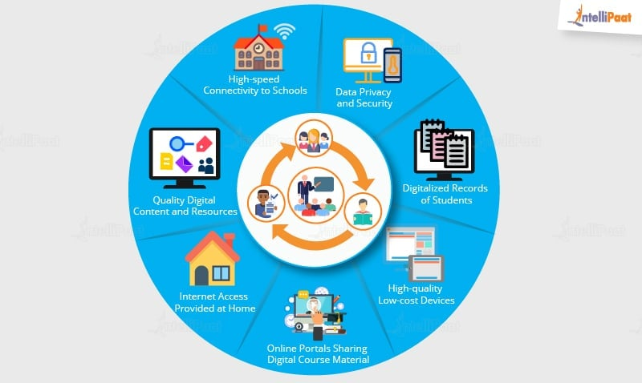
The education industry is flooded with huge amounts of data related to students, faculty, courses, results, and whatnot. Now, we have realized that proper study and analysis of this data can provide insights that can be used to improve the operational effectiveness and working of educational institutes.
Following are some of the fields in the education industry that has been transformed by big data-motivated changes:
- Customized and Dynamic Learning Programs
Customized programs and schemes to benefit individual students can be created using the data collected based on each student’s learning history. This improves the overall student results.
- Reframing Course Material
Reframing the course material according to the data that is collected based on what a student learns and to what extent by real-time monitoring of the components of a course is beneficial for the students.
- Grading Systems
New advancements in grading systems have been introduced as a result of a proper analysis of student data.
- Career Prediction
Appropriate analysis and study of every student’s records will help understand each student’s progress, strengths, weaknesses, interests, and more. It would also help in determining which career would be the most suitable for the student in the future.
The applications of big data have provided a solution to one of the biggest pitfalls in the education system, that is, the one-size-fits-all fashion of academic set-up, by contributing to e-learning solutions.

Example of big data application in the Education Industry
The University of Alabama has more than 38,000 students and an ocean of data. In the past when there were no real solutions to analyze that much data, some of them seemed useless. Now, administrators can use analytics and data visualizations for this data to draw out patterns of students revolutionizing the university’s operations, recruitment, and retention efforts.
Prepare yourself for the industry by going through this Hadoop Interview Questions And Answers!

Big Data Application in Healthcare Industry
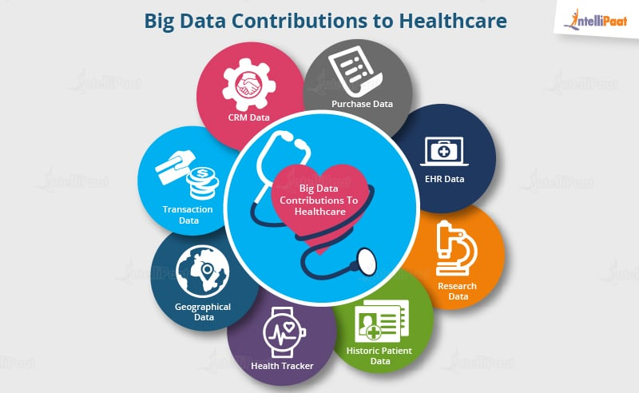
Healthcare is yet another industry that is bound to generate a huge amount of data. Following are some of how big data has contributed to healthcare:
- Big data reduces the costs of a treatment since there are fewer chances of having to perform unnecessary diagnoses.
- It helps in predicting outbreaks of epidemics and also in deciding what preventive measures could be taken to minimize the effects of the same.
- It helps avoid preventable diseases by detecting them in the early stages. It prevents them from getting any worse which in turn makes their treatment easy and effective.
- Patients can be provided with evidence-based medicine identified and prescribed after researching past medical results.
Enroll in Data Analytics Course in Bangalore, if you are interested in learning all about data analytics.

Example of Big Data Application In Healthcare
Wearable devices and sensors have been introduced in the healthcare industry which can provide real-time feed to the electronic health record of a patient. One such technology is Apple.
Apple has come up with Apple HealthKit, CareKit, and ResearchKit. The main goal is to empower iPhone users to store and access their real-time health records on their phones.
Become a master of Hadoop by going through this online Hadoop training in London!

Application of Big Data in Government Sector
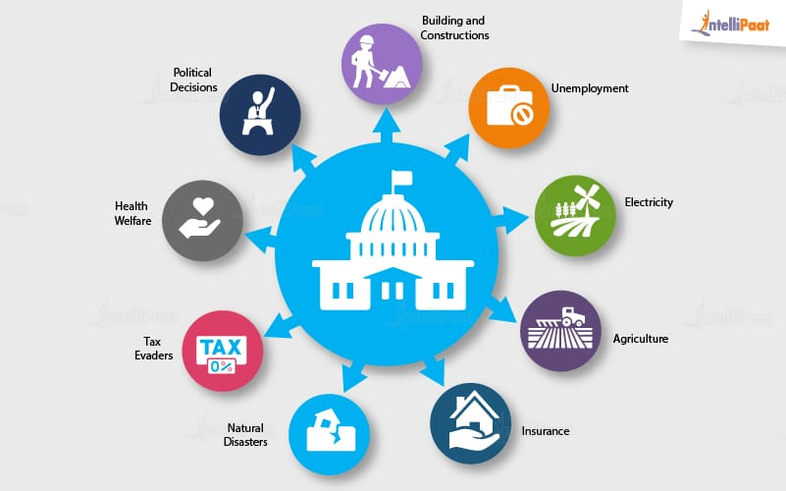
Governments, be it of any country, come face to face with a huge amount of data almost daily. The reason for this is, they have to keep track of various records and databases regarding their citizens, their growth, energy resources, geographical surveys, and many more. All this data contributes to big data. The proper study and analysis of this data, hence, helps governments in endless ways. A few of them are as follows:
Welfare Schemes
- In making faster and more informed decisions regarding various political programs
- To identify areas that are in immediate need of attention
- To stay up to date in the field of agriculture by keeping track of all existing land and livestock.
- To overcome national challenges such as unemployment, terrorism, energy resources exploration, and much more.
Cyber Security
- Big Data is hugely used for deceit recognition in the domain of cyber security.
- It is also used in catching tax evaders.
- Cyber security engineers protect networks and data from unauthorized access.

Example of Big Data Application in Government Sector
Food and Drug Administration (FDA) which runs under the jurisdiction of the Federal Government of the USA leverages the analysis of big data to discover patterns and associations to identify and examine the expected or unexpected occurrences of food-based infections.
Go through the Hadoop Course in New York to get a clear understanding of Big Data Hadoop!

Application of Big Data in Media and Entertainment
With people having access to various digital gadgets, the generation of a large amount of data is inevitable and this is the main cause of the rise in big data in the media and entertainment industry.
Other than this, social media platforms are another way in which a huge amount of data is generated. Although businesses in the media and entertainment industry have realized the importance of this data, they have been able to benefit from it for their growth.
Some of the benefits extracted from big data in the media and entertainment industry are given below:
- Predicting the interests of audiences
- Optimized or on-demand scheduling of media streams in digital media distribution platforms
- Getting insights from customer reviews
- Effective targeting of the advertisements

Big Data Application Example in Media and Entertainment
Spotify, on-demand music-providing platform, uses Big Data Analytics, collects data from all its users around the globe, and then uses the analyzed data to give informed music recommendations and suggestions to every individual user.
Amazon Prime which offers, videos, music, and Kindle books in a one-stop shop is also big on using big data.

Big Data Application in Weather Patterns
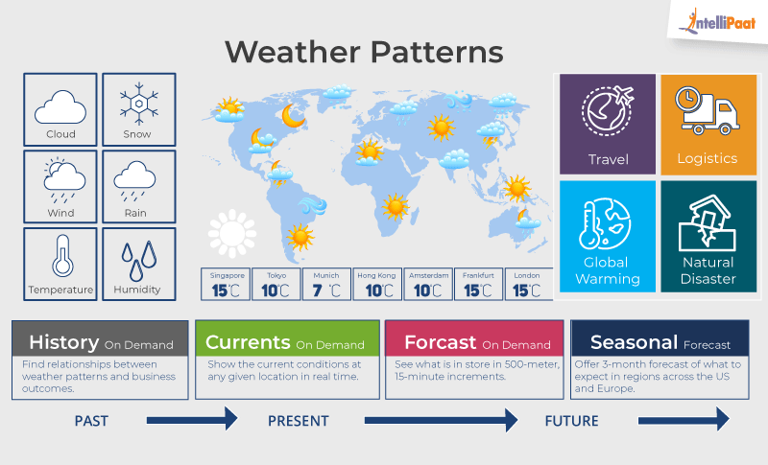
There are weather sensors and satellites deployed all around the globe. A huge amount of data is collected from them, and then this data is used to monitor the weather and environmental conditions.
All of the data collected from these sensors and satellites contribute to big data and can be used in different ways such as:
- In weather forecasting
- To study global warming
- In understanding the patterns of natural disasters
- To make necessary preparations in the case of crises
- To predict the availability of usable water around the world

Big Data Application Example in Weather Patterns
IBM Deep Thunder, which is a research project by IBM, provides weather forecasting through high-performance computing of big data. IBM is also assisting Tokyo with improved weather forecasting for natural disasters or predicting the probability of damaged power lines.
Want to become a master in Big Data technologies? Check out this Hadoop Training in Toronto!

Big Data in Transportation Industry
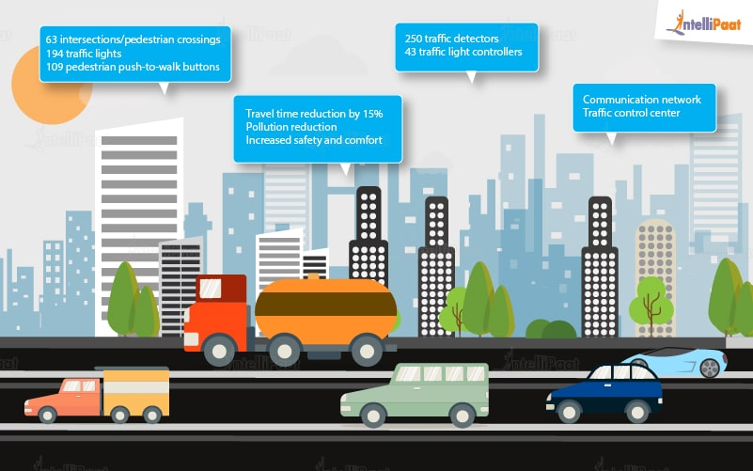
Since the rise of big data, it has been used in various ways to make transportation more efficient and easy. Following are some of the areas where big data contributes to transportation.
- Route planning: Big data can be used to understand and estimate users’ needs on different routes and multiple modes of transportation and then utilize route planning to reduce their wait time.
- Congestion management and traffic control: Using big data, real-time estimation of congestion and traffic patterns is now possible. For example, people are using Google Maps to locate the least traffic-prone routes.
- The level of traffic: Using the real-time processing of big data and predictive analysis to identify accident-prone areas can help reduce accidents and increase the safety level of traffic.

Example
Let’s take Uber as an example here. Uber generates and uses a huge amount of data regarding drivers, their vehicles, locations, every trip from every vehicle, etc. All this data is analyzed and then used to predict supply, demand, location of drivers, and fares that will be set for every trip.
And guess what? We too make use of this application when we choose a route to save fuel and time, based on our knowledge of having taken that particular route sometime in the past. In this case, we analyzed and made use of the data that we had previously acquired on account of our experience, and then we used it to make a smart decision. It’s pretty cool that big data has played parts not only in big fields but also in our smallest day-to-day life decisions too.

Big Data Application in Banking Sector
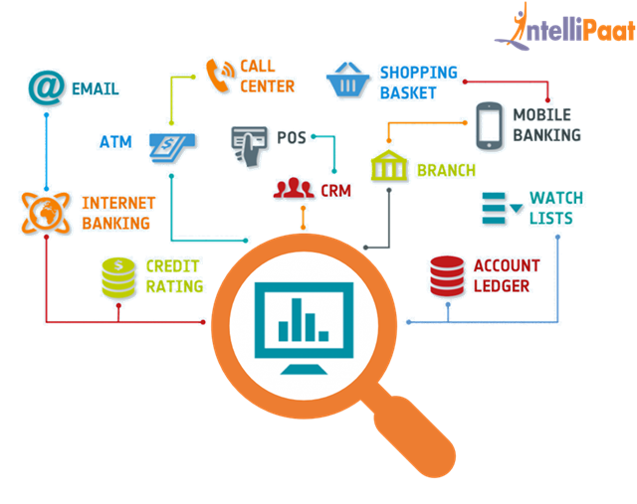
The amount of data in the banking sector is skyrocketing every second. According to the GDC prognosis, this data is estimated to grow 700 percent by the end of the next year. Proper study and analysis of this data can help detect any illegal activities that are being carried out such as:
- Misuse of credit/debit cards
- Venture credit hazard treatment
- Business clarity
- Customer statistics alteration
- Money laundering
- Risk mitigation

Big Data in Marketing
Traditional marketing techniques were based on the survey and one-on-one interactions with the customers. Companies would run advertisements on radios, TV channels, and newspapers, and put huge banners on the roadside. Little did they know about the impact of their ads on the customer.
With the evolution of the internet and technologies like big data, this field of marketing also went digital, known as Digital Marketing. Today, with big data, you can collect huge amounts of data and get to know the choices of millions of customers in a few seconds. Business Analysts analyze the data to help marketers run campaigns, increase click-through rates, put relevant advertisements, improve the product, and cover the nuances to reach the desired target.
For example, Amazon collected data about the purchase done by millions of people around the world. They analyzed the purchase patterns and payment methods used by the customers and used the results to design new offers and advertisements.

Big Data in Business Insights
One of the best Big Data applications we can see in modern industries is generating business insights. Around 60 percent of the total data collected by various enterprises and social media websites is either unstructured or didn’t get analyzed by them. This data if used correctly, can solve a lot of problems related to profits, customer satisfaction, and product development. Luckily, companies are now getting aware of the importance of using the latest technologies to manage and analyze this data more effectively.
One of the companies named Netflix is using Big Data to understand the user behavior, the type of content they like, popular movies on the website, similar content that can suggest to the user, and which series or movies should they invest in.

Big Data in Space Sector
Space agencies of different countries collect huge amounts of data every day by observing outer space and information received from satellites orbiting the earth, probes studying outer space, and rovers on other planets. They analyze petabytes of data and use them to simulate the flight path before launching the actual payload in space. Before launching any rocket, it is necessary to run complex simulations and consider various factors like weather, payload, orbit location, trajectory, etc.
For example, NASA is collecting data from different satellites and rovers about the geography, atmospheric conditions, and other factors of mars for their upcoming mission. It uses big data to manage all that data and analyzes that to run simulations.

